**Assignment-2**

**Problem Statement:**

Explain the below linux commands with an example. Share the screenshot of each

command with the output:

1. pwd

2. vi

3. touch

4. mkdir

5. rm

6. ls

7. echo

8. cat

9. who

10.cd

11.date

12.cal

13.mv

14.cp

15.which

**Solution:**

**1. pwd**:

Linux pwd (print working directory) command displays your location currently you are working on. It will give the whole path starting from the root ending to the directory.

**Syntax**:

pwd

**Example:**

Example of pwd command.

Open a terminal and type pwd, press the enter key. User directory path will be displayed in the below screenshot, my path is **“/home/cloudera”** and my current location is **cloudera**.

As I am using putty, so my screenshots will be shown in putty software.

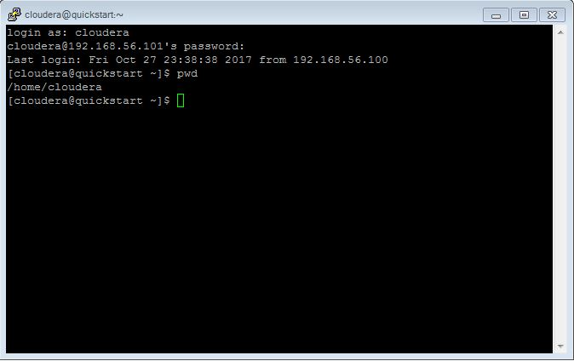

2. **vi:**

Linux vi (visual editor) command it displays vi editor. To start vi open terminal and type vi command followed by file name. If users file is in some other directory, user can specify the file path. And if in case, users file doesn't exist, it will create a new file with the specified name at the given location.

**Syntax**:

vi <fileName>

**Example:**

Example of vi command.

vi /home/cloudera /file1.txt

then we need to press i for <insert> a file, and then for store it we need to press <esc> key and : <colon> with ‘wq’

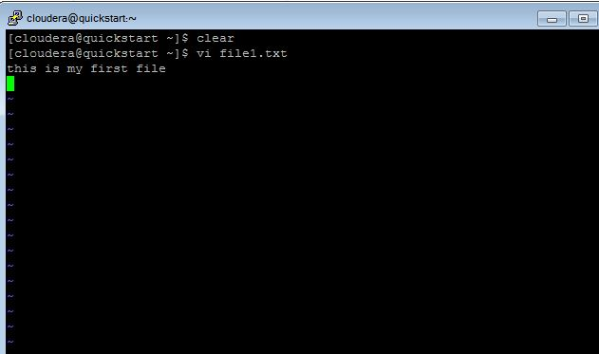

3. **touch:**

The touch command is the easiest way to create new, empty files. It is also used to change the timestamps (i.e., date and time of the most recent access and modification) on existing files and directories.

**syntax:**

touch [option] file_name(s)

**Example:**

Open terminal and type **“touch file1”** and press enter key as shown in screen shot below. In the same screen shot user can verify that **“file1”** file is got created.

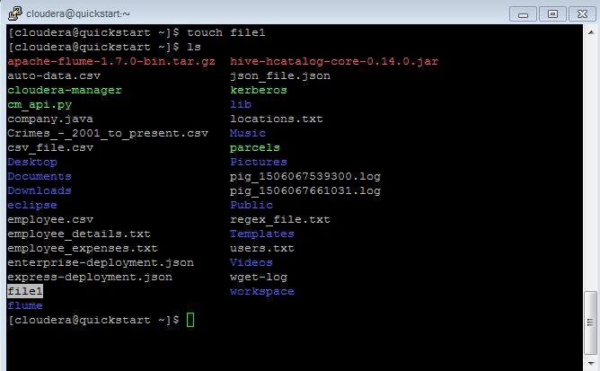

4. **mkdir:**

The mkdir stands for 'make directory'. With the help of mkdir command, user can create a new directory wherever he/she want in his system. Just type "mkdir <dir name> , in place of <dir name> type the name of new directory, you want to create and then press enter.

**Syntax**:

mkdir <dirname>

**Example:**

mkdir dir1

In above example, I am in “**/home/cloudera**” directory. I have made a directory 'created' by passing command "**mkdir dir1**".

As shown in below Screen Shot command is entered in Terminal and in Screen Shot “dir1” folder is got created in **/home/cloudera** path.

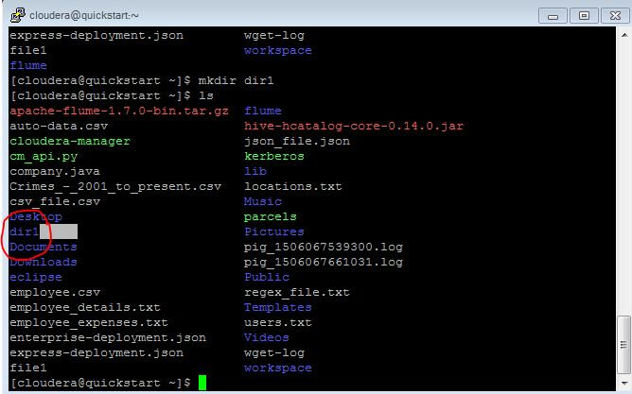

5. **rm:**

Linux command rm stands for remove files or directories. this command deletes the specified files and directories.

**Syntax:**

rm [options] [-r directories] filenames

**Example:**

rm file1

Above command will delete the “file1” file from user directory and a directory named “dir1” also as shown in below screen shot.

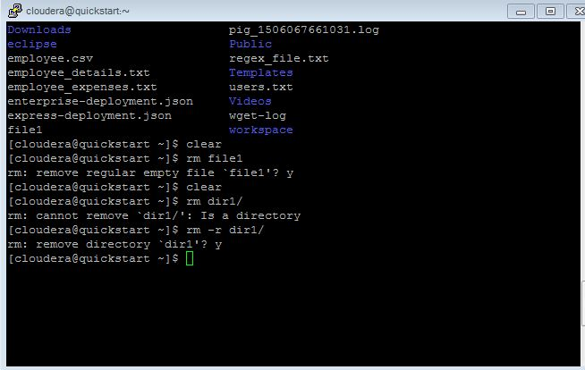

6. **ls:**

The ls is the list command in Linux. It will show the full list or content of your directory. Just type ls and press enter key. The whole content will be shown.

**Syntax:**

ls

**Example:**

ls

Below, you can see, after entering ls command, we got whole content list of /home/cloudera directory.

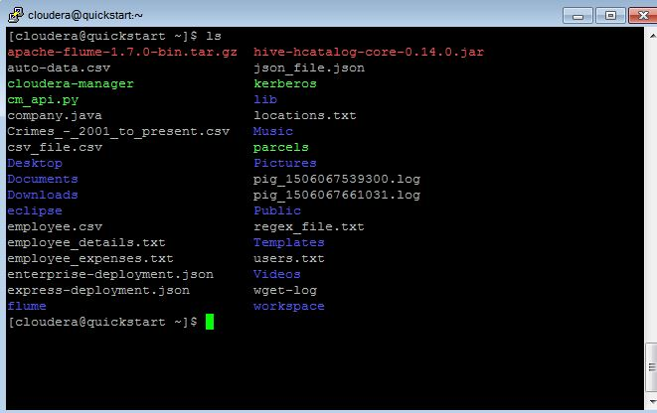

7. **echo:**

Echo linux command is used to write a string to a file or terminal itself.

**Syntax:**

echo string_name

**Example**:

echo i am keshav rana

as shown in below entered string name is written.

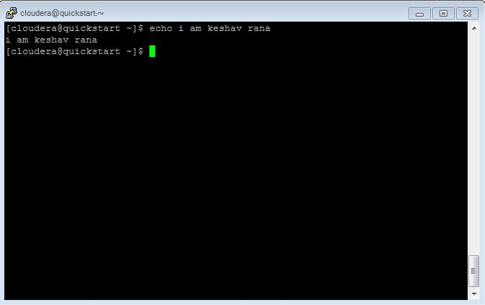

8. **cat**

Linux cat command: to display file content

The 'cat' command can be used to display the content of a file.

**Syntax:**

cat <fileName>

**Example:**

cat locations.txt

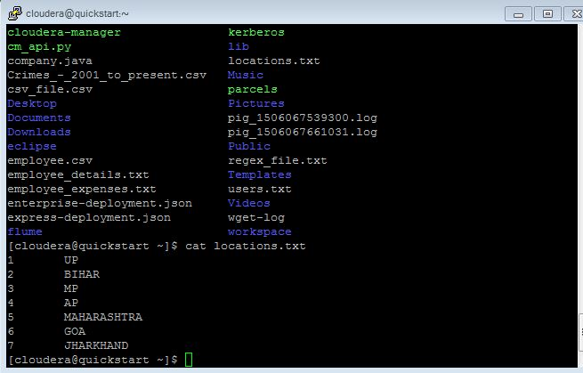

9. **who:**

who linux command get the information on currently logged in users.

**Syntax:**

who

Example:

Give who command and terminal will display output as shown below.

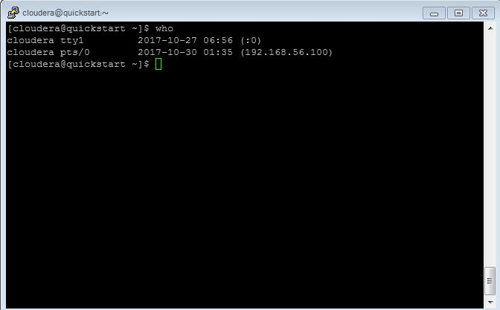

10. **cd**

The "cd" stands for 'change directory' and this command is used to change the current directory i.e; the directory in which the user is currently working.

**Syntax:**

cd <dirname>

**Example:**

cd /home/cloudera

On entering the above command in linux, here user directory is changed from / i.e. root to /home/cloudera as shown in below screens shot.

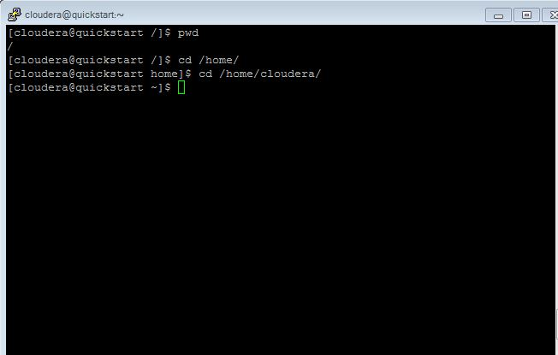

11. **date:**

The date command displays date, time, time zone, etc.

**Syntax:**

date

**Example:**

As shown in below screen shot current date of system is displayed with date command.

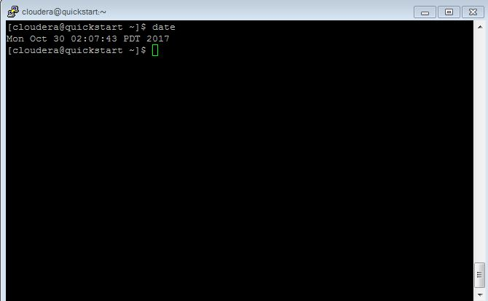

12. **cal**

The 'cal' term stands for calendar. It displays current month's calendar with current day highlighted.

**Syntax:**

cal

**Example:**

As shown in below snapshot cal command has highlighted current date in current month.

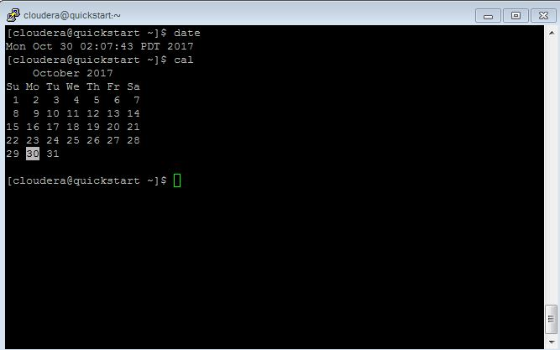

13. **mv**

Linux mv command is used to move existing file or directory from one location to another. It is also used to rename a file or directory. If you want to rename a single directory or file then **'mv'** option will be better to use.

**Syntax:**

mv source_file_name destination_file_name

**Example:**

**mv file1 created**

Here locations.txt is moved from /home/cloudera path to home/cloudera/Desktop as shown in screen shot you can see user has entered a mv command and in screen shot locations.txt is available in created folder refer below screen shot:

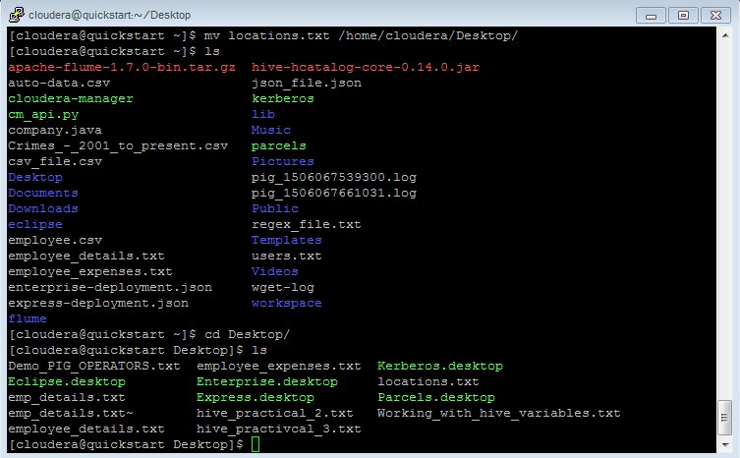

14. **cp**

'cp' means copy. 'cp' command is used to copy a file or a directory.

**Syntax:**

cp <existing file name> <new file name>

As you can see in the highlighted form, locations.txt file is been copied from /home/cloudera to /home/cloudera/Desktop

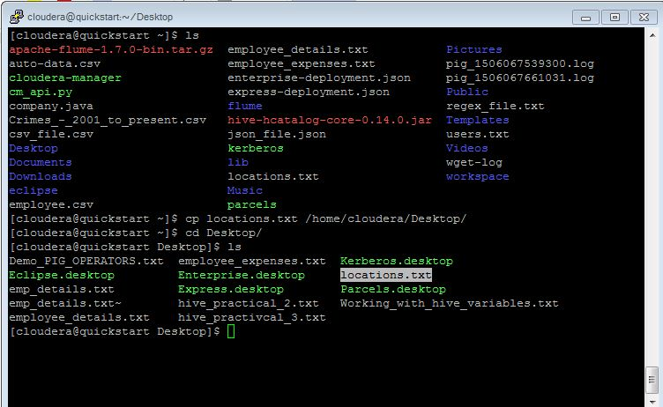

15. **which:**

Locate the executable file associated with a given command which returns the pathnames of the files (or links) which would be executed in the current environment, had the filename (or filenames) been given as a command (or commands) in a strictly POSIX-conformant shell. It does this by searching the paths in the PATH environment variable for executable files matching the names of the arguments.

**Syntax:**

which [filename] ...

Example:

Which file1

On executing above command, as shown in below screen shot , path of locations.txt is located.

